

Family Parking Project

**Google Technologies for Cloud and Web Development Workshop**

**Engineering in Computer Science**

**La Sapienza University**

**Abstract**

*There is no doubt that the winning idea in the current age of the rapid development of the technology is no more the idea with the super creative features and the very exclusive properties which cannot be found anywhere else, instead it is the one which simply solve one of the users real problems and satisfy his needs sufficiently no matter how simple it is. Thus, the importance of any new idea depends on* ***the importance*** *of the user problem this idea solves, and the evaluation of this idea, as a result, will be mainly based on* ***How*** *sufficiently the real application of this idea will solve this problem to the user. For example, a simple idea like "Whatsapp" with no new real invention in the idea, comparing to the previous messaging systems, to gain over 600 million active users by October 2014****[1]*** *means that no matter how simple your idea is, the most important is to satisfy user needs cleverly and distinctly. In this domain, family parking application is one of those simple application that solves one of the most important and frequent problems within the family life. It is a new solution to solve the problem of sharing a car between the members of the family. In such case where there is more than one member using the same car, the problem of finding the last parking position where the last one who used the car parked is a real problem for all the other members sharing this car and family parking system is solving this problem with set of clever features that will be interesting to each family to use it in their daily life activities. Maybe it is the new positive member of each family having this problem, the member who will have a very accurate memory, and a very developed monitoring system that let him always ready to answer every other member of the family when he ask “where is the shared car parked now?”.*

**Team members**

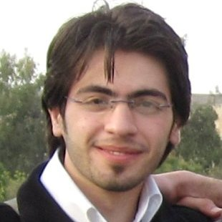

Software engineer graduated from the Aleppo University, Syria. Master student in computer science at la Sapienza University. Because of his experience as a creative researcher at Nawatt Ltd, Obaida was mainly responsible for the documentation, preparing, collecting and repressing the user tests ‘results, preparing the presentations, and representing the group during the milestones’ presentations.

***Obaida Hanteer***

Informatics engineer graduated from La Sapienza University, Rome, Italy. Master student in computer science at La Sapienza University. Freancesco has a very good experience as an Android programmer. Thus, his main responsibilities in the project were defining the needed technologies for developing, optimizing the algorithm of automatic parking, and Android programming.

***Francesco Nobile***



Informatics engineer graduated from La Sapienza University, Rome, Italy. Master student in computer science at La Sapienza University. Nazzarenohas a very good ability to learn quickly is eager to every new in the technology. His responsibilities were: analyzing, developing and testing the server side of the app with python, initializing the Github account and introducing it to the team to know how to use it.

***Nazzareno Marziale***

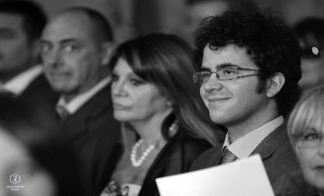

Informatics student at La Sapienza University, Rome, Italy. Mauro has a very good awareness about the latest tools and technologies in mobile and web programming. His responsibilities were: mainly developing the iOS version of the application, Initializing the application website, following the google analytics to study those statistics to build a knowledge about the user’s use of the app, and organize the meetings with the mentor.

***Mauro Piva***

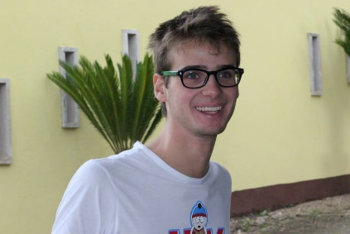

Informatics student at La Sapienza University, Rome, Italy. Georgia is the reason behind the idea of family parking app to be found. She is the idea finder and her responsibilities in the project were: taking part of developing the iOS version of the application, leading the group meetings with her suggestions about the perfect implementation, evaluating the application through distributing it to real users.

***Giorgia Ramponi***



**To be Continued ….**

**References:**

[1] Wikipedia, “WhatsApp”, Last modified [17 Jan 2015], Accessed [18 Jan 2015] <http://en.wikipedia.org/wiki/WhatsApp>